Foundations of Programming
Assignment No. : 9
PROBLEM STATEMENT:
Write a program in C to check whether the given number is an Armstrong number or not.
An Armstrong number is an integer with three digits such that the sum of the cubes of its digits is equal to the number itself.
Example: 371
OBJECTIVE:
• To understand the concept of Armstrong numbers.
• To practice arithmetic operations in C.
• To develop logical thinking using loops and conditional statements.
THEORY:
An Armstrong number (also called a narcissistic number) is a number that is equal to the sum of the cubes of its digits. For a three-digit number abc, it is an Armstrong number if:
a³ + b³ + c³ = abc
For example, 371 is an Armstrong number because:
3³ + 7³ + 1³ = 27 + 343 + 1 = 371.
PLATFORM:
Linux
ALGORITHM:
- Start
- Input a three-digit number num
- Store original number in temp
- Set sum = 0
- Repeat until num > 0
Find digit: digit = num % 10
Calculate cube: digit³
Add to sum: sum = sum + digit³
Remove last digit: num = num / 10
- Check if sum == temp
If yes → Print "Armstrong number"
Else → Print "Not Armstrong number"
- Stop

FLOWCHART :
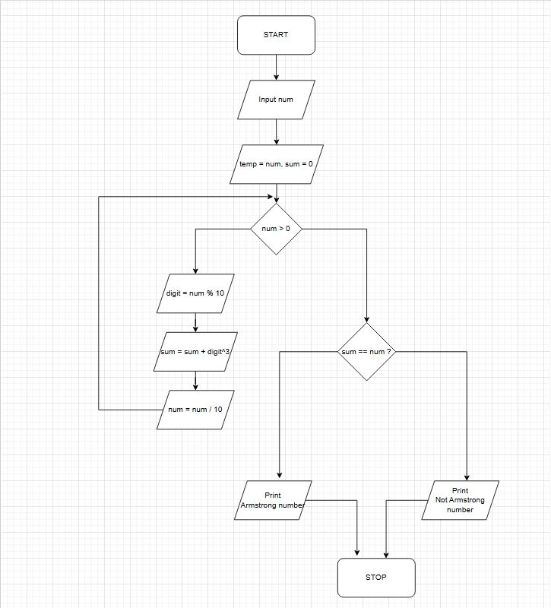

CODE :
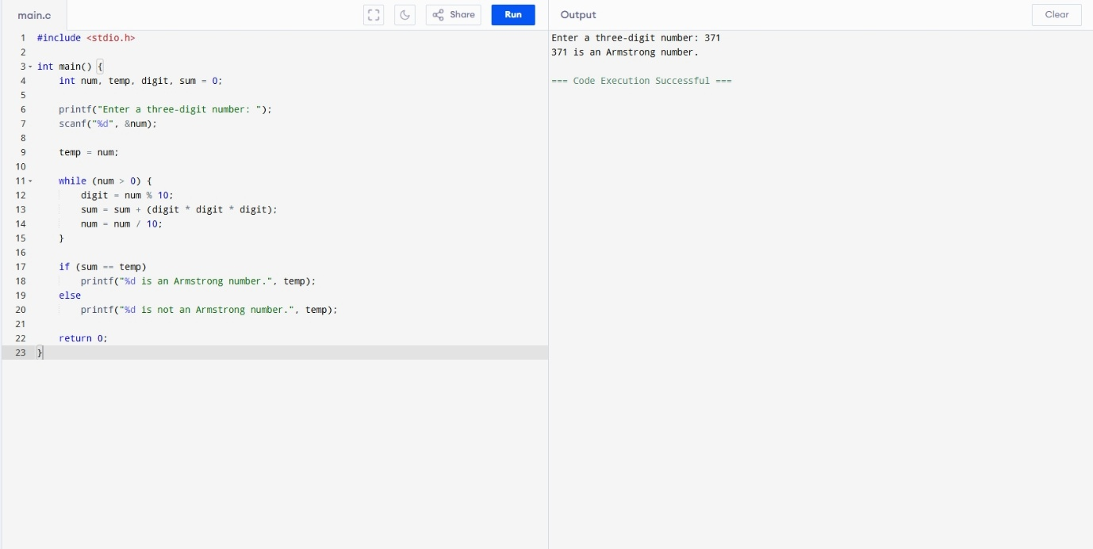
INPUT:
Enter a three-digit number.
Example Input:
371
OUTPUT:
Example Output:
371 is an Armstrong number.
CONCLUSION:
Thus, we have successfully written a C program to check whether a given number is an Armstrong number using loops and arithmetic operations.
FAQs:
1. What is an Armstrong number?
2. Why is the Armstrong number concept important in programming?
3. How does this program work step by step?

